Yes — you can build the ILMA Super Admin Portal into a multi-industry management platform without rebuilding everything from scratch. But the key is to design the architecture for expansion from day one.
Your current goal is to manage ILMA Education ERP customers. Your longer-term goal could be to manage customers across education, healthcare, real estate, retail, HR, accounting, and other industries through one central portal.
The smart approach is to build one central platform with industry-specific modules, rather than creating a separate admin portal for every industry.
1. What your future platform could look like
ILMA Platform Control Center
One login · One customer registry · One central administration system
Identity & Access
Users, roles, invitations, permissions
Business Operations
Billing, subscriptions, expenses
Analytics & Monitoring
Usage, performance, alerts
Industry Modules
Education, healthcare, real estate and more
Customer Applications
ILMA Education ERP · Future industry-specific products
The central platform handles the functions that nearly every business application needs. Each industry application handles its own specialized workflows.
2. The most important design decision: separate the platform from the products
I would structure the system into three layers.
Layer 1 — Core platform
Reusable across all industries: customer accounts, login and identity, access management, subscription plans, billing, audit logs, notifications, integrations and central analytics.
Layer 2 — Industry modules
Education, healthcare, real estate, retail and other industries, each with its own business rules, specialized permissions, data models and workflows.
Layer 3 — Customer organizations
Each customer gets the appropriate product, enabled features, user roles, subscription and isolated business data.
This is consistent with established multi-tenant SaaS architecture guidance, which emphasizes reusable shared services alongside appropriate tenant isolation.

Microsoft Learn
+1
3. How you would expand into other industries
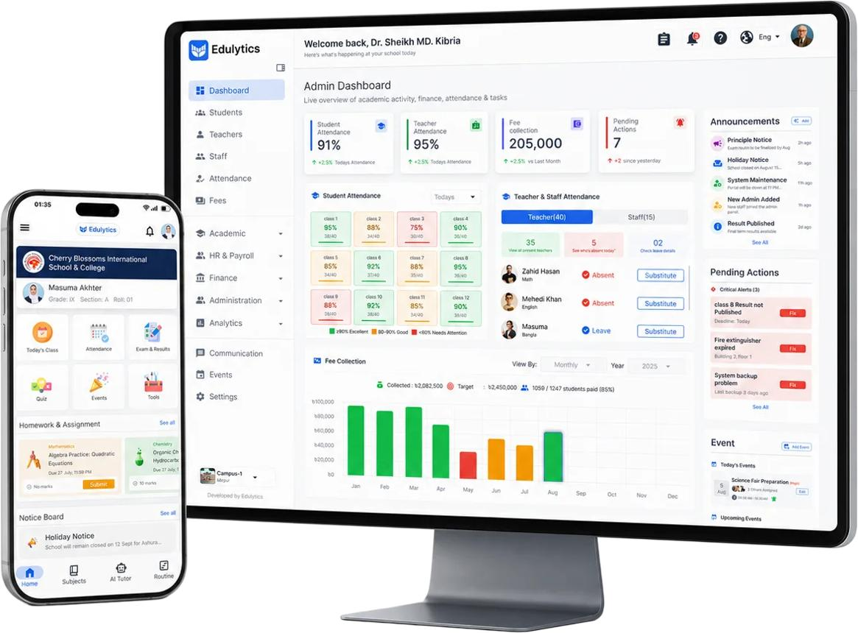
Add to Favorites
Education — ILMA ERP
Current product
Admissions, attendance, fees, exams, parent portals, AI tools and campus management.
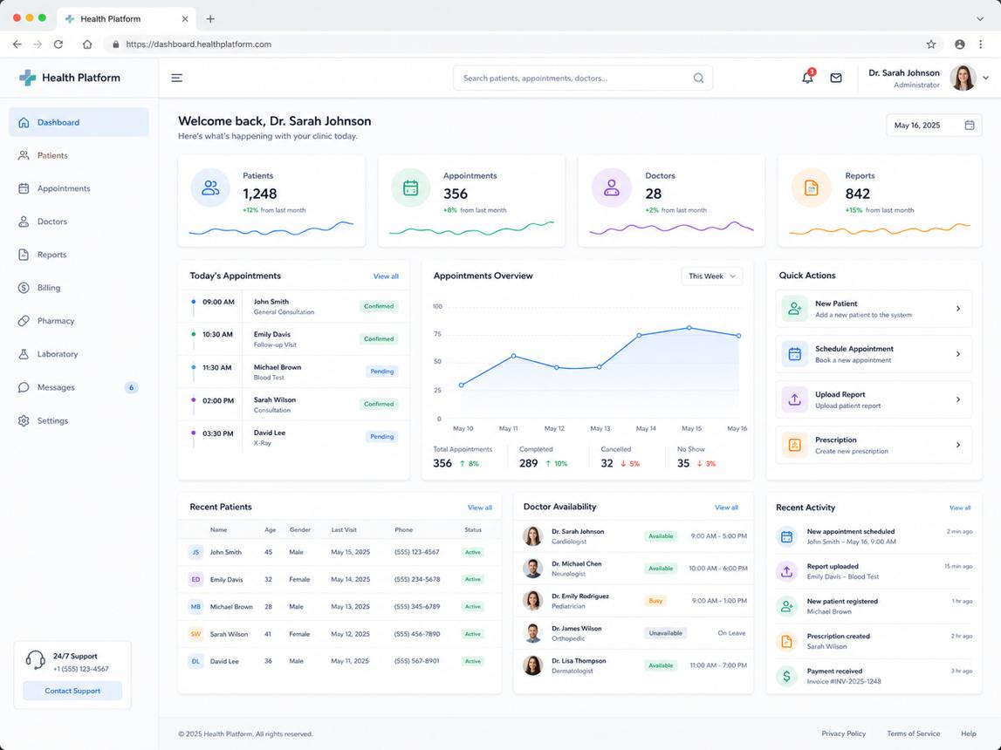
Add to Favorites
Healthcare management
Appointments, patient records, staff, billing and clinic operations. Requires additional privacy and regulatory safeguards.
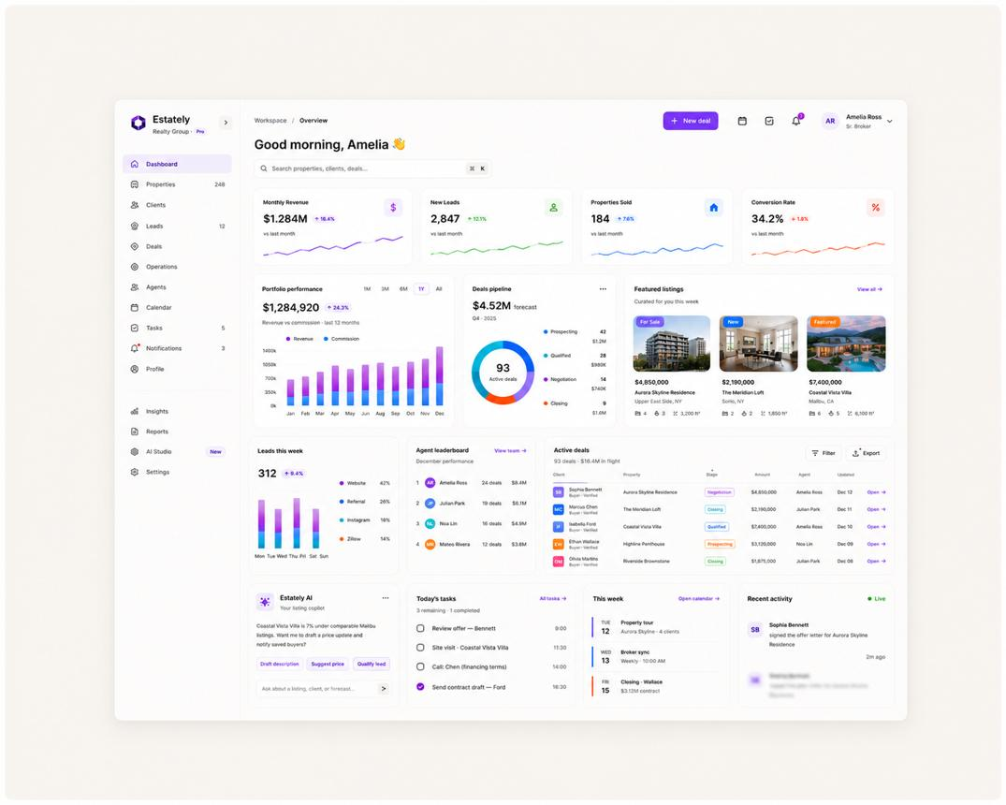
Add to Favorites
Real estate management
Property listings, buyers, owners, agents, commissions, follow-ups and sales pipelines.
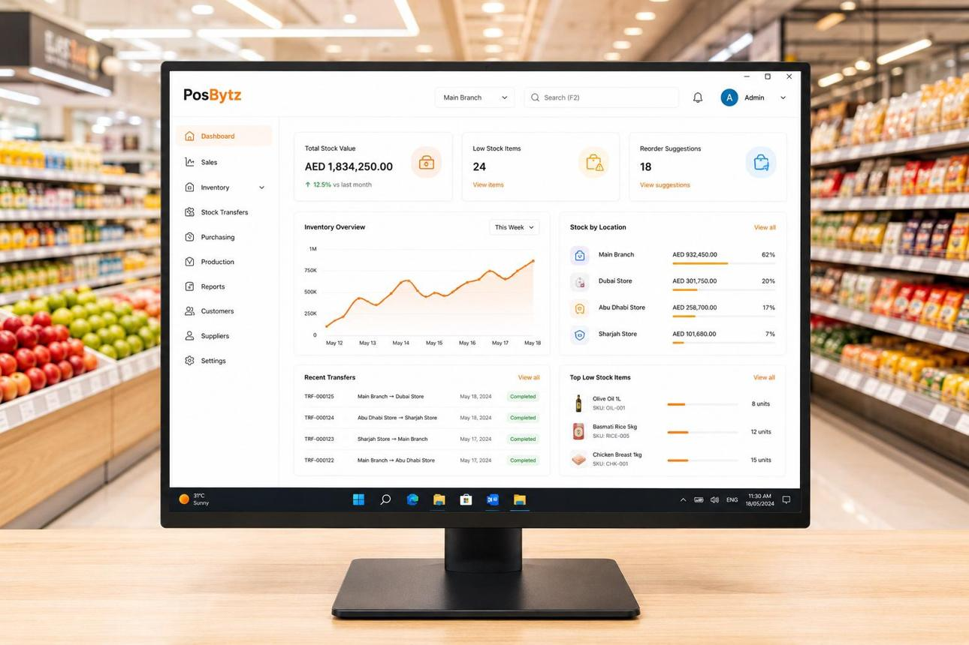
Add to Favorites
Retail and inventory
Products, stock, purchases, sales, branches and supplier management.
The shared portal would manage these products centrally, while each industry's application would remain specialized.
4. How to minimize future development effort
Build these capabilities into the foundation:
- A product registry: register new products and industries without rewriting the customer-management system.
- A module and feature registry: configure which modules are available for each product, subscription and customer.
- Configurable subscription plans: define features, limits, pricing and billing periods without hardcoding each customer.
- A common integration layer: standardize APIs, webhooks, notifications and payment integrations.
- A shared analytics framework: collect consistent events across products while respecting privacy and permissions.
- Tenant isolation: enforce strict data separation between customers, including when they use different industry products.
- Centralized deployments and monitoring: manage releases, service health and errors without requiring manual changes for each customer.
One important distinction: sharing infrastructure does not mean forcing every industry into the same database schema or business workflow. Healthcare records, educational records and property transactions have different requirements. Some services can be shared; specialized data and functionality should remain separate where necessary.

AWS Documentation
+1
5. My recommendation for ILMA
Start with Education ERP, but design the administration platform as a reusable foundation from the beginning. You do not need to build healthcare or real estate software today. You do need to avoid architecture that makes adding them expensive later.
Also, don't start with dozens of microservices or a complicated plugin marketplace. A well-structured modular application with clear module boundaries is often the more practical starting point. Split components into independent services only when scale, security, deployment or operational needs justify it.
Your target should be a single control center that lets your team:
- Add a new product or industry.
- Register and onboard its customers.
- Assign subscriptions and feature access.
- Manage users, billing, renewals and support.
- Monitor usage and performance.
- Expand the platform without duplicating its core management functionality.
One final question: Are you planning to build this platform solely for products owned by Al-Mantiq, or do you eventually want third-party software companies to connect their own products and manage their customers through your portal too?
That distinction determines whether you need a multi-product management platform or a full SaaS platform for multiple software vendors.

